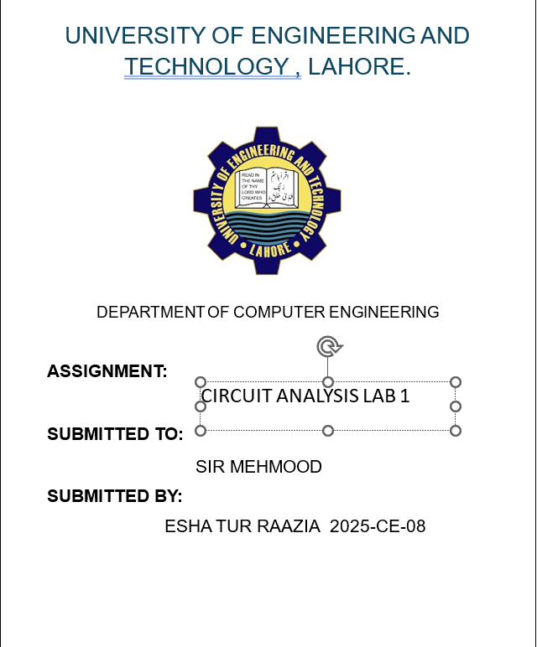
Experiment # 1
SIGNAL GENERATOR AND OSCILLOSCOPE
1. Use the signal generator and the oscilloscope to perform the following tasks.
2. Build circuit ‘A’ shown below in Figure 1.
3. Set the signal generator to generate a sinusoidal signal with a frequency of 100 Hz and peak-to peak voltage of 5V.
4. Set up one probe across input signal, and another across R1 and R2 alternatively.
5. Measure and draw all the voltages and time related parameters on the graphs below.
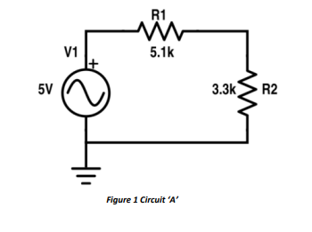
Resistor | Input voltage | RMS Voltage | P-P Voltage
R1 | 5 | 1.77 | 2.5
R2 | 5 | 1.77 | 2.5

PROCEDURE:
STEP 1
Open Proteus and click the 'P' (Pick Devices) button.
Search for RES and add them to the device list.
Place two resistors R1 and R2 in a series arrangement.
STEP 2
Double-click R1 and set the resistance to 5.1k.
Double-click R2 and set the resistance to 3.3k.
STEP 3
Connect the positive terminal of V1 to one end of R1.
Connect the other end of R1 to R2
Connect the remaining end of R2 back to the negative terminal of V1
Place a Ground terminal from the Terminals Mode and connect it to the negative line of the circuit.
STEP 4
Select the Digital Oscilloscope from the Virtual Instruments Mode.
Connect Channel A to the output of the Alternator (to measure input voltage).
Connect Channel B to the junction between R1 and R2 (to measure voltage across R2).
STEP 5
Click the Play button at the bottom left to start the simulation.
When the Oscilloscope window appears, adjust the Time base to 2ms and Volts/Div to 1V for both channels to view the sinusoidal waveforms clearly.
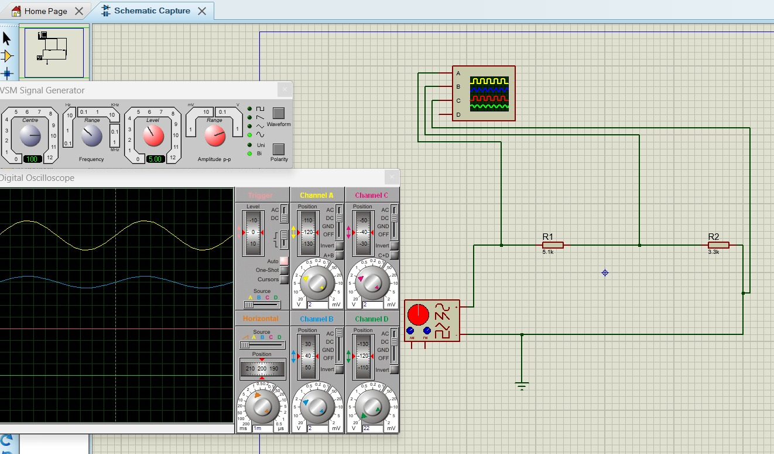

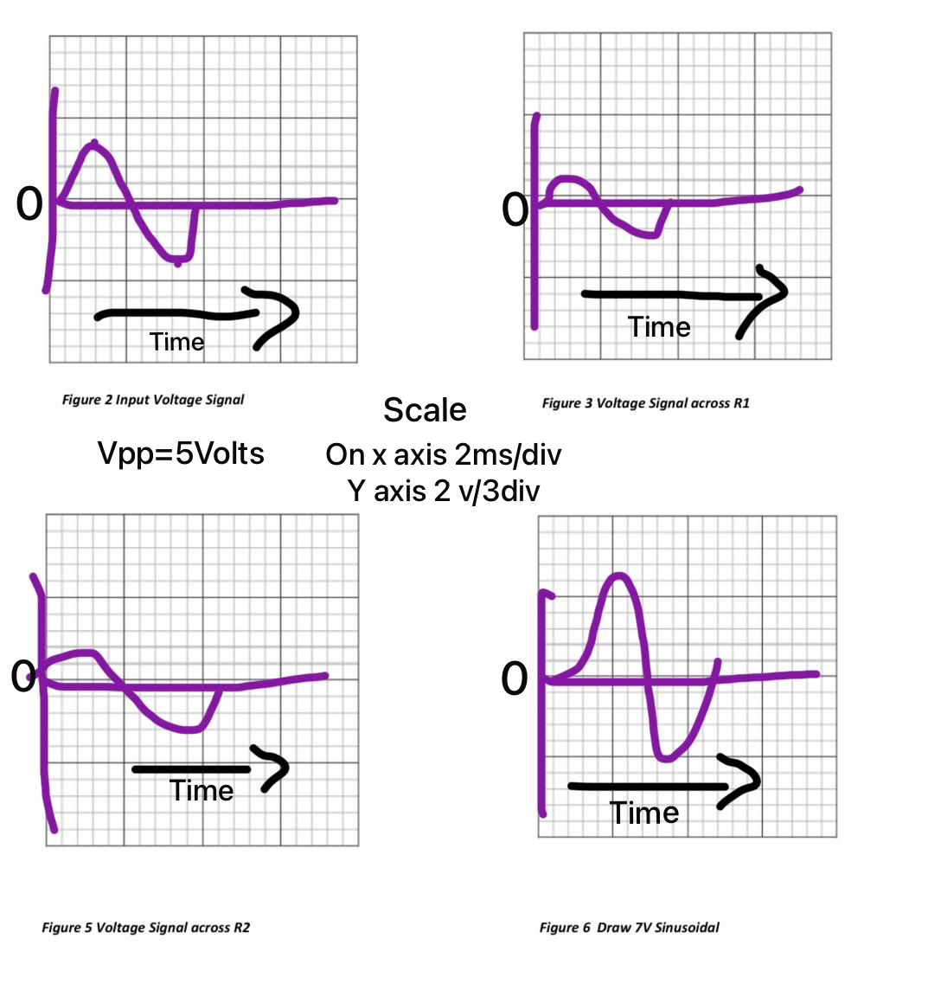

Experiment # 2
SIGNAL GENERATOR AND OSCILLOSCOPE
1. Use the signal generator and the oscilloscope to perform the following tasks.
2. Build circuit ‘B’ shown below in Figure 7.
3. Set the signal generator to generate a sinusoidal signal with a frequency of 200 Hz and peak-to peak voltage of 7V.
4. Set up one probe across input signal, and another across R1, R2 and R3 alternatively.
5. Measure and draw all the voltages and time related parameters on the graphs below.
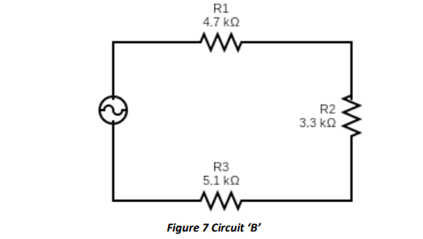
RESISTOR | INPUT VOLTAGE | RMS VOLTAGE | P-P VOLTAGE
R1 | 7 | 0.89 | 2.51
R2 | 7 | 0.62 | 1.76
R3 | 7 | 0.97 | 2.73
R1 AND R2 | 7 | 1.5 | 4.27
R2 AND R3 |  | 1.59 | 4.49
PROCEDURE:
STEP 1
Open Proteus and click the 'P' (Pick Devices) button.
Search for RES and add them to the device list.
Place three resistors R1 , R2 and R3 in a series arrangement.
STEP 2
Set the Amplitude to 3.5V (this gives a total of $7\text{V}$ Peak-to-Peak) and set the Frequency to 200Hz.
Double-click R1 and set the resistance to 4.7K.
Double-click R2 and set the resistance to 5.1k.
Double-click R3 and set the resistance to 3.3k.
STEP 3
Connect the Alternator to R1, then R1 to R2 and R2 to R3.
Complete the loop by connecting the bottom of R3 back to the Alternator.
Attach a Ground terminal to the return path (negative side) of the source.
STEP 4
Connect Channel A of the Oscilloscope to the source to monitor 7V input.
To measure individual resistors move the probe of Channel B to the specific nodes surrounding that resistor.
STEP 5
Click the Play button at the bottom left to start the simulation.
When the Oscilloscope window appears, adjust the Time base to 1 or 2ms and Volts/Div to 1V for both channels to view the sinusoidal waveforms clearly.
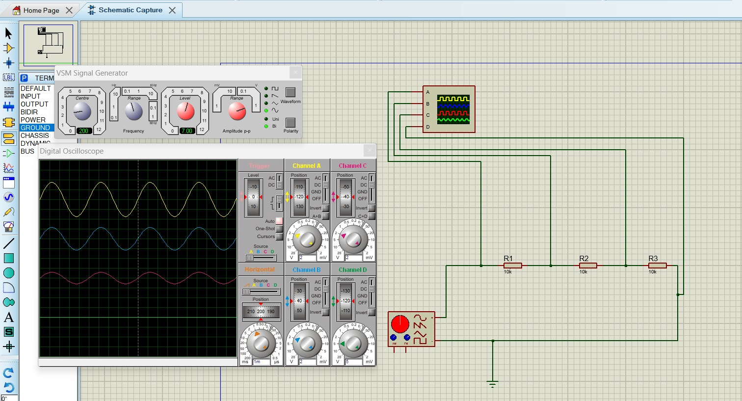

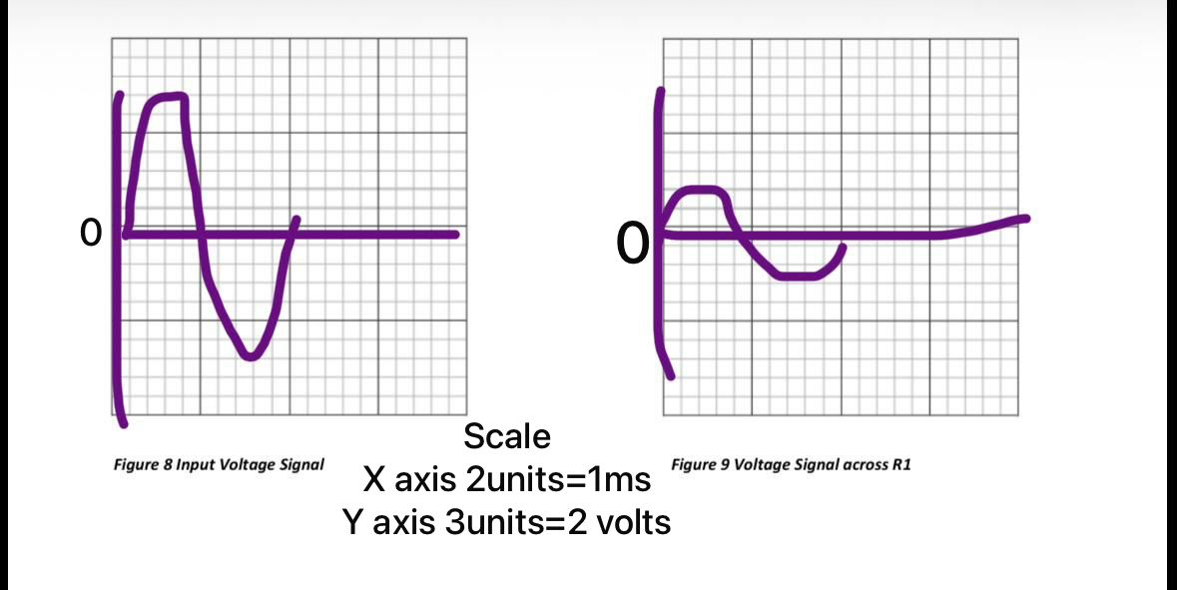
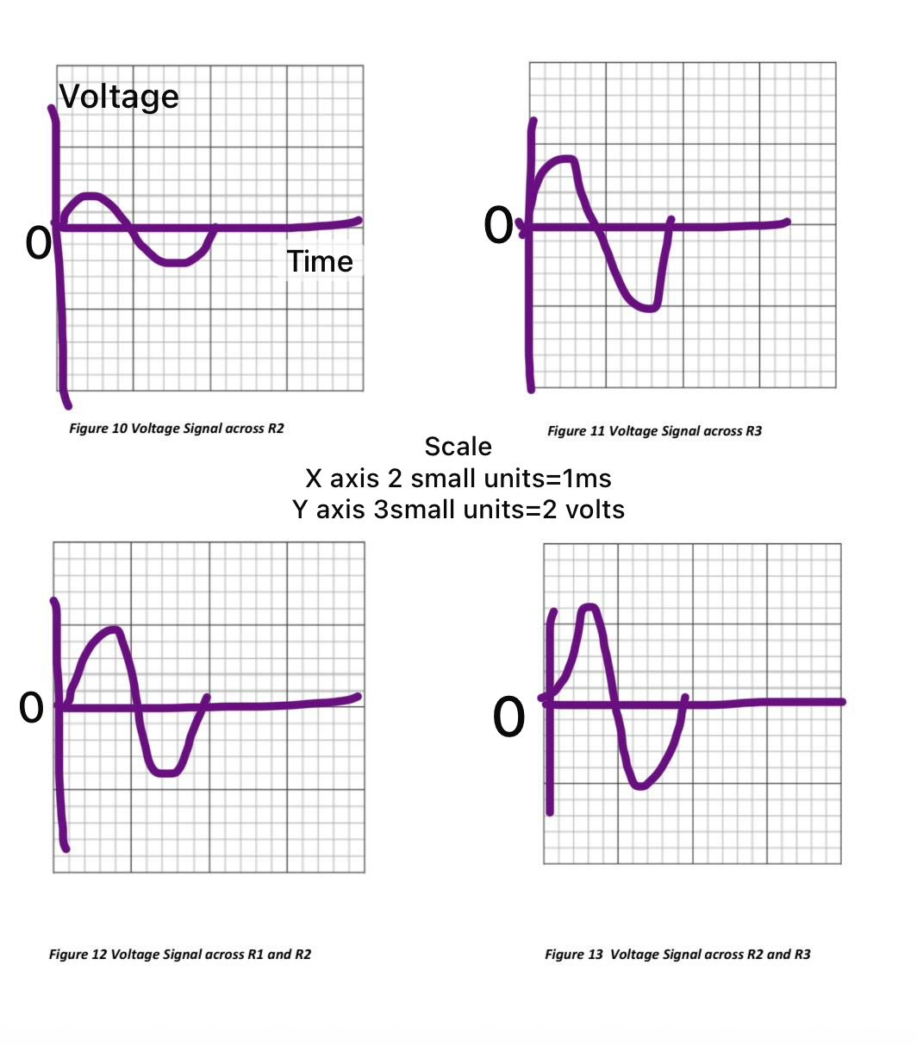

POST LAB QUESTIONS
- Define Ohm’s law.
Ohm’s law states that the current flowing through the conductor between two points is directly proportional to the voltage, provided all the physical conditions remain constant.
- What is resistor?
A resistor is a device that offers opposition to the flow of current.
- How resistor works?
A resistor works by creating internal collisions between moving electrons and the atoms of the resistor material, which physically slows down the electrical current. This process converts some of the electrical energy into heat, effectively regulating the amount of power that passes through a circuit.
- What is your inference from the input and output waveforms on
Oscilloscope?
By comparing waveforms on an oscilloscope, we can infer the Voltage Drop, which shows how much the resistor reduced the signal's strength (amplitude). Additionally, if the waves align perfectly in time (no phase shift), it confirms the circuit is purely resistive and not affected by other components.
- Show calculations of 7V input signal (Figure 10) from signal generator. a. Voltage calculations (Following volt/dev and number of boxes of oscilloscope) b. Frequency/Period calculations (Following Steps in frequency measurements section) c. Current calculation (Ohm Law)
Peak voltage = Vpp/2 = 7/2 = 3.5
Frequency = 200 hz Time = 1/200 = 0.005
R(t) = R1 + R2 + R3 = 13.1k ohm
Peak current
Ip = Vp/R(t)
Ip = 0.267 Ma
I rms = V rms/ R(t)
I rms = 0.189 mA

